Gridless Wireless Network  
Responsibilities, Roles, & Elements Tables

**Team name**:

Off the Grid

**Team members:**

Ian Schneier

Linda Palacios

Weikang Zhang

Xucheng You

Jingwen Luo

Alec Motazedi

**Project Sponsor:**

### Prof. Alan Mickelson

## ***Responsibilities, Roles, Elements***

### ***Use Case 1: Restore Communications***

|  |  |  |
| --- | --- | --- |
| **Responsibilities** | **Subsystem** | **HW or SW** |
| Be powered for 72 hrs | Power System | HW: efficient battery to provide the power at least one week |
| Scan for other devices | Communications | SW: Automatically search for Wi-Fi enabled devices in coverage area |
| Create a local area network | Communications | SW: People can use the network if they are in the range of the network |
| G.W.N devices connect with each other and with users as well, creating a mesh network | Communications | SW: Signal process |
| Provide a 2.4 GHz signal | Communications | SW: Frequency should be 2.4 GHz |
| The network connects with the GMS network | Wireless | SW: People can communicate with others who are not in the network |

## 

### ***Use Case 2: Power Management***

|  |  |  |
| --- | --- | --- |
| **Responsibilities** | **Roles** | **HW or SW** |
| Convert battery voltage to different value to power various submodules | Power System | HW: DC/DC converter |
| Modify power consumption of components to maximize battery life. | MCU | HW: PMU |
| Transmit the Wi-Fi signal up to 1W (30dBm) | Communications | HW: Antenna Amplifier |
| Provide a omnidirectional coverage area up to 1 Km distance | Communications | HW: Omnidirectional Antenna |
| Transmit up to 5 Km distance | Communications | HW: Directional Antennas |

### ***Use Case 3: Service Applications***

|  |  |  |
| --- | --- | --- |
| **Responsibilities** | **Roles** | **HW or SW** |
| Get the location of devices connected to the device created network | Wireless | SW: The government can use the machine to locate individuals |
| Provide a VOIP service for people to communicate with rescuers | Wireless | SW: Transceiver |
| Messaging service to receive media and other information from network users | Wireless | SW: Transceiver |

### 

### ***Use Case 4: Quick Deployment***

|  |  |  |
| --- | --- | --- |
| **Responsibilities** | **Roles** | **HW or SW** |
| Device successfully powers on | Power Manager | HW: PMU |
| Device generates network signal for devices to connect to | Communications | HW/SW: Antenna and Transceiver |
| Detect and connect to another Wi-Fi network to provide internet access through the device | Communications | SW: Transceiver |

# 

## ***Functional Decomposition***

### ***Transceiver mode***

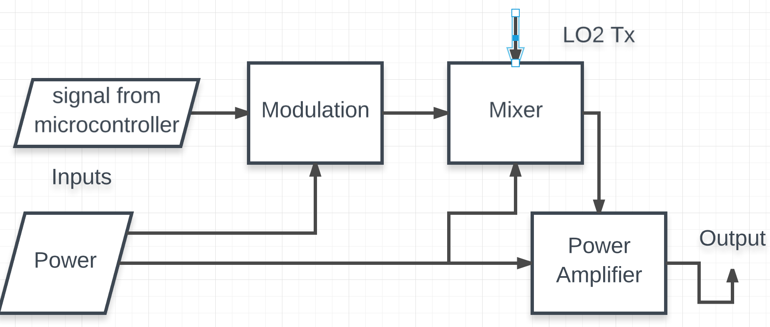

|  |  |
| --- | --- |
| Module | Modulation |
| Inputs | Signal from microcontroller |
| Outputs | Signal on certain frequency (2.4GHz) |
| Functionality | Phase shift to frequency shift conversion |

|  |  |
| --- | --- |
| Module | Mixer |
| Inputs | Modulated signal |
| Outputs | The difference of original signals |
| Functionality | Creates new frequencies from two signals applied to it. |

|  |  |
| --- | --- |
| Module | Power amplifier |
| Inputs | Mixed signal |
| Outputs | High power output signal |
| Functionality | Converts a low-power [radio-frequency](https://en.wikipedia.org/wiki/Radio-frequency) [signal](https://en.wikipedia.org/wiki/Signal_(electrical_engineering)) into a higher power signal. |

### ***Embedded system mode***

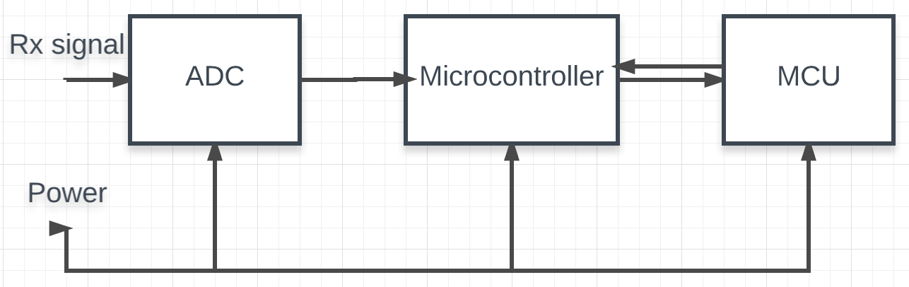

|  |  |
| --- | --- |
| Module | ADC |
| Inputs | Rx analog signal |
| Outputs | Converted Digital signal |
| Functionality | Analog to digital conversion |

|  |  |
| --- | --- |
| Module | Microcontroller |
| Inputs | Digital signal |
| Outputs | Processed digital signal |
| Functionality | Digital signal processing to be ready for MCU |

|  |  |
| --- | --- |
| Module | MCU |
| Inputs | Processed digital information |
| Outputs | Stored digital data to microcontroller for communication |
| Functionality | Store digital information for later transmitting. |